**NEAR EAST UNIVERSITY**

**FACULTY OF PHARMACY**

**PHA 501 GRADUATION PROJECT**

**WRITING GUIDE**

**Cover, Special Pages, Volume, Print and Page Layout**

The cover assembly is as shown on **page 2.**

There should be a blank page between the inner cover page and front cover also between the back page of the outer cover and the last page of the thesis.

The color of covers should be maroon.

The writing language is **English.**

Written text (except References and Appendix) should not exceed **30 pages.**

Typeface to be used should be **Arial, Times** or **Times New Roman.**

The letter size of the main text should be **12 pt** and footnotes should be **10 pt.**

The writing area should be aligned to both sides **(justify).**

Tables and figures which do not fit on a single page may include smaller characters.

There should be one space after punctuation in writing. Space must not be left before punctuation.

Pages must be in A4 size. There should be **4 cm gap at the left side of each page, 3 cm gap at the top and bottom edges and 2.5 cm gap at the right edge**. The specified text block framework should not be deviated **(Figure 1).**

**NEAR EAST UNIVERSITY**

**FACULTY OF PHARMACY**

**(12 pt)**

**TITLE OF PROJECT**

**(20 pt)**

**Student Name SURNAME (Student Number)**

**(12 pt)**

**NEPHAR 501**

**GRADUATION PROJECT**

**(12 pt)**

**ADVISOR**

**Title Name SURNAME**

**(12 pt)**

**NICOSIA**

**,**

**T.R.N.C.**

**-**

**2015**

**(12 pt)**

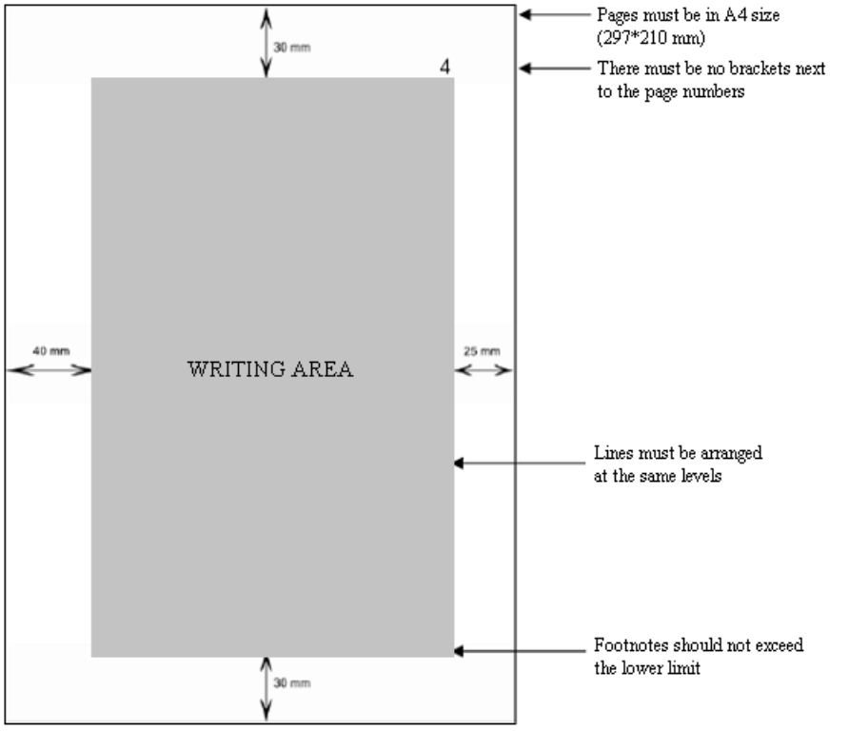

**Figure 1.** Layout

**Acceptance and Approval Page**

This page shows the approval of the project by the project consultants and the Dean of the Faculty of Pharmacy after the project is defended. The name of the thesis advisor, title and signature must be present on this page. Approval page must be numbered with "i". Example is as follows.

i

**Near East University Faculty of Pharmacy**

“Title” NEPHAR 501 Graduation Project has been accepted and evaluated to be succesful.

Date:

**Advisor**

**This graduation project has been accepted by the Faculty Board of Directors on**

**/ / 20...**

Prof. Dr. İhsan ÇALIŞ

Dean

ii

**ACKNOWLEDGMENTS**

Acknowledgments should be written as short and concise as possible and must not exceed one page. The layout of the page must be the same as the summary page and must be numbered with "ii". There should be acknowledgments to people with direct contributions in the preparation of project work and there should be also acknowledgments to the people and organizations who are not directly related but have contributed besides their regular tasks.

iii

**Thesis Plan and Title Numbering system must be prepared in the following format;**

**TABLE OF CONTENTS**

Prepared as in the following example. Page must be numbered with "iii".



**TABLE OF CONTENTS**

**(EXAMPLE)**

**ACCEPTANCE AND APPROVAL**

**…**

**…**

**…**

**…**

**…**

**…**

**…**

**…**

**…**

**…**

**…**

**…**

**…**

**…**

**…**

**…**

**...**

**.....**

**.**

**i**

**ACKNOWLEDGEMENTS**

**…**

**…**

**…**

**…**

**…**

**…**

**…**

**…**

**…**

**…**

**…**

**…**

**…**

**…**

**…**

**…**

**...**

**.....**

**.......**

**.....**

**.**

**ii**

**TABLE OF CONTENTS**

**…**

**…**

**…**

**…**

**…**

**…**

**…**

**…**

**…**

**…**

**…**

**…**

**…**

**…**

**…**

**…**

**...**

**.....**

**............**

**....**

**i**

**ii**

**LIST OF FIGURES**

**…**

**…**

**…**

**…**

**…**

**…**

**…**

**…**

**…**

**…**

**…**

**…**

**…**

**…**

**…**

**…**

**…**

**…**

**…**

**…**

**…**

**…**

**…**

**…**

**.**

**.**

**i**

**v**

**LIST OF TABLES**

**…**

**…**

**…**

**…**

**…**

**…**

**…**

**…**

**…**

**…**

**…**

**…**

**…**

**…**

**…**

**…**

**…**

**…**

**…**

**…**

**…**

**…**

**…**

**…**

**…**

**.**

**v**

**ABSTRACT**

**…**

**…**

**…**

**…**

**…**

**…**

**…**

**…**

**…**

**…**

**…**

**…**

**…**

**…**

**…**

**…**

**…**

**…**

**…**

**…**

**…**

**…**

**…**

**…**

**…**

**…**

**…**

**..**

**vi**

**1.**

**INTRODUCTION**

**…**

**…**

**…**

**…**

**…**

**…**

**…**

**…**

**…**

**…**

**…**

**…**

**…**

**…**

**…**

**…**

**…**

**…**

**…**

**…**

**…**

**…**

**…**

**…**

**1**

**2.**

**NANOTECHNOLOGY IN MEDICINE**

**…**

**…**

**…**

**…**

**…**

**…**

**…**

**…**

**…**

**…**

**…**

**…**

**…**

**…**

**…**

**2**

2.1. Nanotechnology in Medicine

…

…

…

…

…

…

…

…

…

…

…

…

…

…

…

…

…

…

.

.

2

2.2. Nanotechnology in Healthcare Market

…

…

…

…

…

…

…

…

…

…

…

…

…

…

…

4

**3.**

**APPLICATIONS OF NANOMEDICINE IN CENTRAL**

**NERVOUS SYSTEM DISORDERS**

**…**

**…**

**…**

**…**

**…**

**…**

**…**

**…**

**…**

**…**

**…**

**…**

**…**

**…**

**…**

**…**

**.**

**6**

3.1. Challenge: Passing Blood Brain Barrier (BBB)

…

…

…

…

…

…

…

…

…

…

…

10

3.2.

Nanoengineered Mater

ials (NM) Employed For

N

eurodegenerative

Disorders

…

…

…

…

…

…

…

…

…

…

…

…

…

…

…

…

…

…

…

…

…

…

…

…

…

...

13

3.2.1.Nanoparticles

…

…

…

…

…

…

…

…

…

…

…

…

…

…

…

…

…

…

…

…

…

…

15

3.2.2. Nanozymes

…

…

…

…

…

…

…

…

…

…

…

…

…

…

…

…

…

…

…

…

…

…

..

17

3.2.3. Nanofibers and Carbon Nanotubes

…

…

…

…

…

…

…

…

…

…

…

…

…

..

17

3.2.4. Nanosuspensions and Nanoemulsions

…

…

…

…

…

…

…

…

…

…

…

…

.

20

3.4. Probable Toxicity due to Nanoengineered Materials

…

…

…

…

…

…

…

…

…

23

**4.**

**SUMMARY**

**AND OUTLOOK**

**…**

**…**

**…**

**…**

**…**

**…**

**…**

**…**

**…**

**…**

**…**

**…**

**…**

**…**

**…**

**…**

**…**

**…**

**.**

**24**

**REFERENCES**

**…**

**…**

**…**

**…**

**…**

**…**

**…**

**…**

**…**

**…**

**…**

**…**

**…**

**…**

**…**

**…**

**…**

**…**

**…**

**…**

**…**

**…**

**…**

**…**

**…**

**…**

**..**

**26**

**APPENDIX A**

***3 cm***

**LIST OF FIGURES (EXAMPLE)**

**Figure 2.1.** Nanomedicine publications and patents worldwide………………………..4

**Figure 2.2.** Sectorial and country breakdown of nanomedicine publications…………..5

***4 cm***

**Figure 3.1.** Polymeric nanoparticles (NPs) and their advantages and

***2.5 cm***

disadvantages………………………………………………………………8

**Figure 3.2.** Drug transport mechanisms of nanoparticles………………………............11

**Figure 3.3.** IIlustrations of (a) functionalized and stable nanoparticles within

a suspension (nanosuspension) and (b) the typical structure of a

drug-loaded nanocapsule……………………………………………………13

***3 cm***

***LIST OF TABLES (EXAMPLE)***

**Table 2.1.** Mean molecular weight and degree of acetylation………………………..3

**Table 2.2.** Accelerated stability testing…………………………………….…………5

***2.5 cm***

***4 cm***

**Table 3.1.** Conditions for the Baeyer-Villiger oxidation.............................................11

**Table 4.2.** Comparison of the 1H-NMR data of methyl esters....................................18

**Table 4.3.** Comparison of the 1H-NMR data of carboxylic acids................................21

**Abstract**

If there will be a summary of the project (abstract), it should take place right after the acknowledgments page; and it should be numbered with Roman numerals. In the abstract, the purpose of the thesis, scope, the method (s) and the conclusion (s) must be stated clearly and concisely. However, in the abstract, there should not be "Aim", "Methods", "Results" as sub-headings. **(maximum 250 words)**

Abstract title must be written in bold with uppercase and must be centered after two blank lines (intervals) from the upper limit line of the writing area. The name of the project should be written again after two blank lines (intervals), in bold capitals. After the title, leaving a gap in the range of 1.5 intervals, the text of the summary should be written with 1 interval between lines. The abstract of the project can be written with a smaller font size than the one used in the main text **(10 pt).**

Abstract text must also include at least three keywords related to the thesis text. Keywords should be written after skipping a line (interval). The keywords to be selected should be about the work, but should not include the title words. They should be convenient with Medical Subject Headings (MeSH). After the keywords, if there is any organization that contributed to the thesis, their names and Project numbers should be written.

You will find an abstract example below.

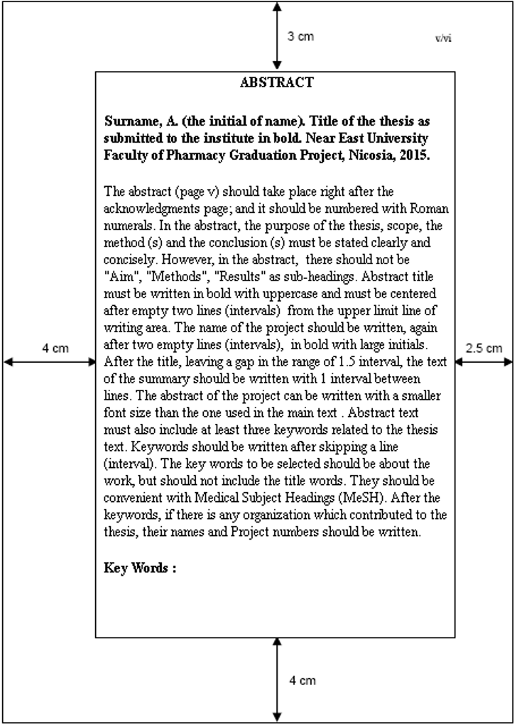



**Page Numbering**

All pages should be numbered except the inner cover.

Acknowledgments, Summary (if necessary), Table of Contents, Symbols and Abbreviations, the thesis front pages, such as figures and tables should be numbered in small letters and Roman numerals as "i, ii, iii, iv, v ..."; Other pages starting with the introduction should be numbered as "1, 2, 3, 4, 5 ...".

Page numbers should be placed on the lower right side of the page.

**Line Spacing**

In the main text, there should be **1.5 line** spacing. Figure Captions and descriptions of the tables, quotations and references also should be written with the same range.

Line spacing should be **1 line** in the footnotes.

The spacing between paragraphs should be **1.5 lines**.

Each new paragraph starts from the beginning of lines. All section headings; Acknowledgements, Abstract, all Directories and References, second- and third-degree head titles should be written in separate new pages.

There should be 1.5 line spacing before and after the main text, figures, tables and between the formulas. Between figures and below figure descriptions, tables and above table descriptions there should be also 1.5 lines spacing.

**Section and Sub-Sections**

Chapter titles should be 12 points.

The first-degree section titles, the first letter of each word in the second- and third-degree titles should be written uppercase, others should be written lowercase.

All chapter titles should be written in bold font..

**Figures, Tables and Formulas**

Figures should be included on the page they were first discussed or on next page.

Figure captions and descriptions should be included under the figures and the text block should be centered between the left and right sides of the figure.

Table title and descriptions should be written above the table, text fields should be initiated at the beginning of the line. The descriptions of tables and figures should be ended with a full stop

All tables, figures and formulae should be numbered with only numeral digits. They should be numbered separately, independently of each other among themselves in each section.

**Placing Formulas**

While numbering formulae, there should be the phrase of "Formula" at the beginning of numbers, and they should be numbered in order within that section.

However, while referring in the text, they would be written as "Formula 2.1".

**Written text "Introduction, Result, Discussion and Conclusion" should not exceed 30 pages.**

The letter size of the main text should be **12 points**, footnotes should be **10 points.** The writing area must be aligned 2 sides **(justify)**.

**INTRODUCTION**

In this chapter, the reader should be informed with preliminary information about the thesis subject. All the information should be supported with references but any materials, methods, information which can lead to arguments must not be included in this chapter.

Pre-existing literature must be reviewed in the context of studies. Subject problems must be detected and evaluated in accordance with the purpose, scope and assumptions. Possible hypotheses to be tested within this project must be explained. After enough information, aim/purpose should be written very clearly and shortly at the end of the chapter.

**MATERIAL AND METHODS**

Test methods of assumptions created in the Introduction and General Information section must be described in detail in this section. Laboratory observations and techniques used, the survey and other measurement modes must be described. Data acquisition forms and test groups must be identified if any. Required statistical assessments must be described as how they were done.

**RESULTS**

The data obtained by the methods described in the previous section must be presented in a particular logical, analytical integrity and flow. If necessary, analysis of the data with appropriate statistical methods must be included. In presenting the results, tables, graphics, shapes, images such as photographs should be utilized for better expression.

**DISCUSSION**

The findings are discussed within the framework of the Introduction and General Information section. In this section, contribution to the science of this study must be specified, the original parts must be emphasized. Tested assumptions whether they are accepted or rejected and the accomplishment degree of objectives should be written. In the discussion section, how the assumptions mentioned in the ‘ntroduction and General Information section and the findings of the thesis, support each other, should be focused. In this context, speculative comments should be avoided as much as possible.

**CONCLUSION OR SUMMARY**

In this section, the results obtained from the project work should be written generally but concisely as possible. When necessary, the results may be written item by item. The achievement degree of the scope, mentioned in the iIntroduction section, should be noted.

**REFERENCES**

"REFERENCES" title, must be written in capitals, 3 cm below the upper edge of the page and must be centered.

It is necessary for experimental or survey work.

**CITATIONS**

All sources cited in the project must be written in References section in **alphabetical order**.

***REFERENCES (EXAMPLE)***

**Book - One Author**

Surname, (first letter of the name of the author). (Publication Year). *Book title*. Publication place: Publisher.

**Example 1** Dökmeci, İ. (1988). *Toxicology: Diagnosis and Treatment of Acute poisoning*. Istanbul: Nobel Bookstore.

**Example 2** Bozcuk, A. N. (2005). *Genetics* (2nd ed.). Ankara: Palme Publishing.

**Delivery method inside text: (Last Name, year of publication)**

**Example:** (Dökmeci, 1998)

(Bozcuk, 2005)

**Book - Two Authors**

Surname, (first letter of the name of the author). and Surname, (first letter of the author's name). (Publication Year). *Book title*. Publication: Publisher

**Example 1** Demirdamar, R. and Gümüşel, B. (2011). *Pharmacology*. Ankara: Palme Publishing.

**Delivery method inside text: (Last Name and Lastname, year of publication)**

**Example:** (Demirdamar and Gümüşel, 2011)

**Book - Many Authors**

Surname, (first letter of the name of the author)., Surname, (first letter of the name of the author)., Surname, (first letter of the name of the author)., Surname, (first letter of the name of the author)., Surname, (first letter of the name of the author). and Surname, (first letter of the author's name). (Publication Year). *Book title*. Publication: Publisher.

**Example 1** Akman, Y., Ketenoğlu, O., Güney, K., Kurt, L. and Tuğ, G. M. (2004). *Plant Ecology*. Ankara: Palme Publishing.

**Delivery method inside text: (First Author`s Surname et al., year of publication)**

**Example:** (Akman et al., 2004)

**Book - Legal Entity Authors**

Legal Person. (Publication Year). *Book title*. Publication: Publisher.

**Example 1** TUBITAK. (2002). *Scientific Publishing in the 21st Century*: Targets and Approaches. Ankara: TUBITAK.

**Example 2** Turkish Language Institution. (2005). Turkish Dictionary (10th ed.). Ankara: Turkish Language Institution.

**Book - Translation**

Surname, (first letter of the name of the author). (Publication Year). *Book title* ((the first letter of the author's name). Surname, Trans.). Publication: Publisher. (Source Release Year).

**Example 1** Jawetz, E., Melnick, J. and Adelberg, A. E. (1976). *Medical Microbiology* (M. Akman and E. Gülmezoğlu, Trans.). Ankara: Hacettepe University (1972).

**Publication in a Book (Chapter or Article)**

Surname, (first letter of the name of the author). (Publication Year). Publication name. A. Editor (Jun. / Ed.). *Book title* (pp. Page numbers). Publication: Publisher.

**Example 1** Şimşek, H. ve Öksüzoğlu, G. (1999). *Acute Pancreatitis*. A. Kadayıfçı, Y. Karaaslan and E. Köroğlu (Ed.). Emergency Diagnosis and Treatment (pp. 116-126). Ankara: Psychiatric Association.

**Scientific Journal Article - One Author**

Surname (first letter of the name of the author)., A. (Publication Year). Article title. *Journal Name*, volume (number), page numbers.

**Example 1** Çakın, İ. (2004). Miscellaneous Printing Press Implications and Impact of Printing in Europe. *Info World*,5(2), 153-167.

**Scientific Journal Article - Many Authors**

Surname, (first letter of the name of the author)., Surname, (first letter of the name of the author)., Surname, (first letter of the name of the author)., Surname, (first letter of the name of the author)., Surname, (first letter of the name of the author)., Surname, (first letter of the name of the author). (Publication Year). Article Title. *Journal name*, volume (number), page numbers.

**Example 1** Erkan, S., Tuğrul, B., Üstün, E., Akman, B., Şendoğdu, M., Kargı, E*.* et al. (2003). Turkey Belongs to Preschool Teacher Student Profile Survey. *Hacettepe University Faculty of Education Journal*, 23, 108-117.

**Popular Journal Article - Specific Author**

Surname, (first letter of the name of the author)., (Month, Year). Article Title. *Journal name*, *volume*, page numbers.

**Example 1** Kenar, N. (Nisan 2006). Unregistered employment. *Popular Management*, 9, 44–47.

**Popular Journal Article - Author Not Specific**

Article Title. (Month year). Journal name, volume, page numbers.

**Example 1** Globalising local knowledge. (April 2006). *Focus*, 12, 14-17.

**Newspaper Article**

Surname, (first letter of the name of the author). (Day month Year). Article Title. Newspaper Name, page numbers.

**Example 1** Bayar, Y. (04 April 2006). Is humanity dumb? *Hurriyet*, p. 14.

**Declaration - Published**

Surname, (first letter of the name of the author). (Publication Year). Declaration Name. (First letter of the name of the author). Surname Editor (Ed.). Name of the Book (pp. Page numbers). Publication place: Publisher.

**Example 1** Ucak, N. (2005). Knowledge Production in social science, access and use. O. Horata (Ed.). Periodical Publications in Social Sciences and Information Technology Symposium: 2 April 2005 - Declaration (p. 92-103). Ankara: New Eurasia.

**Declaration - Unpublished**

Speaker Surname, (first letter of the name of the speaker). (Month year). Report Name [Declaration]. Conference Title, Venue.

**Example 1** Tonta, Y. (February 2006). Recent Developments in Information Management: Amazoogle the Cooperation and Open Access [Declaration], Academic Computing, Gaziantep.

**Poster**

Surname, (first letter of the name of the author). (Month year). Poster Name [Poster]. Conference Title, Venue.

**Example 1** Onal, I. (August 2002). Historical perspectives on school Librarianship [Poster]. 68th IFLA General Conference and Council in Glasgow.

**Patent**

Inventor`s Surname, (the first letter of the name). (Publication Year). *Invention Title*, Country Patent No. Publication place: Publisher.

**Example 1** Roast, K. H. (2006). *Heart flowerpot*, U.S. Patent No. D518,755. Washington, DC: U.S. Patent and Trademark Office.

**Counseling Resources - Glossary**

Surname, (first letter of the name of the author). (Publication Year). Work Title. Publication place: Publisher.

**Example 1** Altan, N. (2003). Computer Terms Encyclopedic Dictionary (3rd ed.). Ankara: System Publishing.

**Counseling Resources - Encyclopedia Article**

Surname, (first letter of the name of the author). (Publication Year). Article Title. Work Title (c. Volume number, p. Page number). Publication place: Publisher.

**Example 1** Wayne, O. (1973). Paper and Shipbuilding. *Turkish Encyclopedia* (c. 21, pp. 112-115). Ankara: Ministry of Education.

**Report**

Surname, (first letter of the name of the author). (Publication Year). Title Report (Report No. :). Publication place: Publisher/Preparation Organization.

**Example 1** State Planning Organization. (2004). Review of State Aid Special Commission Report (Report No. DPT: 2681). Ankara: State Planning Organization.

**Thesis**

Surname, (first letter of the name of the author). (Publication Year). Thesis Title. MSc / PhD / qualification thesis in Art, University Name, Location.

**Example 1** Özbaş, Z. Y. (1991). Acidophilus Yogurt Production Techniques. PhD thesis, Near East University, Ankara.

**Laws and Regulations**

Name Law. (Year of acceptance). *Publication Name*, Number, Date Month Year.

**Example 1** Primary Education Law (1961). *T. C. Official Newspaper*, 10705 January 12, 1961.

**Example 2** Law No. 5846 on Intellectual and Art Works of the Law Amending Certain Articles. (1995). *T. C. Official Newspaper*, 22311, June 12, 1995.

**Interview**

Letters, email messages, personal interviews such as phone calls can`t be added to the references due to not being obtainable resources. Interviews can only be referred in the text.

**Electronic Resources – Electronic Version of the Printed Book**

Surname, (first letter of the name of the author) and surname, (first letter of the name of the author). (Publication Year). *Name of the Book* [Electronic version]. Publication place: Publisher.

**Example 1** Başar, H. (1999). *Classroom Management* [Electronic version]. Istanbul: Ministry of Education.

**Electronic Resources - Electronic Version of the Printed Article**

Surname, (first letter of the name of the author) and Surname, (first letter of the name of the author). (Publication Year). Article Name [Electronic version]. *Journal Name*, volume (number), page numbers.

**Example 1** Akman-Demir, G., Yeşilot, N. and Serdaroğlu, P. (2006). Neurological involvement in Behçet's Disease: Clinical Characteristics, diagnosis and treatment [Electronic version]. *Journal of Neurological Science*, 23(1), 3-7.

**Electronic Resources - Article**

Surname, (first letter of the name of the author). (Publication Year). Article Title. *Journal Name*, volume (number), page numbers. Access: Day Month Year, ***http: // network address***

**Example 1** Yıldırım, A., Ekici, K. M. ve Şahım, T. (t.y.). Understanding the Importance of Synergistic Businesses Management Process. *Information Valley*, 1(2). Access: 04 April 2006, [***http://www.bilgivadisi.net/idas/index.php?option=com_content&task=view&id=86&ıtemid=59***](http://www.bilgivadisi.net/idas/index.php?option=com_content&task=view&id=86&ıtemid=59)

**Electronic Resources - Article or Material in Databases**

Surname, (first letter of the name of the author). (Publication Year). Article Title. *Journal Name*, volume (number), page numbers. Access: Day Month Year, Database Name, Registration/Article No.

**Example 1** Coşkun, T., Bozoklu, S., Özenç A. ve Özdemir, A. (1998). Effect of hydrogen peroxide on permeability of the main pancreatic duct and morphology of the pancreas. *The American Journal of Surgery*, 176(1), 53-58. Access: April 25, 2006 ScienceDirect.

**Electronic Resources - Reports**

Name of Institution. (Month year). *Report Title* (Report No.). Access: Day Month Year, ***http: // network address***

**Example 1** State Planning Organization. (July 2004*). e-Transformation Turkey Project Short-Term Action Plan: Assessment Report* (Report No. 2). Access: 02 April 2006, ***http://212.175.33.22/kdep/rapor/ kdephaziran2004.pdf***

**Electronic Resources - Anonymous Network Page**

Source Title. (t.y.). Access: Day Month Year, ***http: // network address***

**Example 1** Ethics of Science and Fraud in science. (t.y.). Access: 04 April 2006, [***http://www.aek.yildiz.edu.tr/bilim.htm***](http://www.aek.yildiz.edu.tr/bilim.htm)

**Electronic Resources - Network-Accessed Network Page**

Surname, (first letter of the name of the author). (Publication Year). Page Name. Access: Day Month Year, Network Site Name: ***http: // network address***

**Example 1** Gordon, C. H., Simmons, P. and Wynn, G. (2001). What it is, and how to avoid it. Access: 04 April 2006, the University of British Columbia Networking Site: ***http://www.zoology.ubc.ca/bpg/advising/ Plagiarism.htm***

**Electronic Resources - Web Site**

Web Site or Organization Name. (Publication Year). Access: Day Month Year, ***http: // network address***

**Example 1** Tema Foundation. (t.y.). Access: 04 April 2006, [***http://www.tema.org.tr***](http://www.tema.org.tr)

**Electronic Resources - News, Discussion Groups or Forum Messages**

Surname, (first letter of the name of the author). (Day month Year). Message Subject [Message No.]. Access: Information/Discussion Group/Board name, ***http: // web address***

**Example 1** Işık, E. (5 November 2003). Plant Library [Message No. 8]. Access: Kutup-L, [***http://listproc.metu.edu.tr.9000/reguser/archives/kutupl/kutupl.log200311/msg00008.html***](http://listproc.metu.edu.tr.9000/reguser/archives/kutupl/kutupl.log200311/msg00008.html)

**Appendices**

Appendices should be named according to these presentation order; Appendix A, B, C ....... If there is a reference to the appendix in the text, it should be as `See Appendix A`etc. Each appendix section must start at the beginning of the page. Appendices should be given respectively after the resources in the report, but should not include page numbers and in the "Table of Contents", they should be given after resources without page numbers as shown in the example.

**REFERENCES**

Bektaş, Ş., Mamedov, F., Khashman, A. (2001). **Graduate Studies: A Complete Reference**, Near East University, ISBN 8359-06-01, Nicosia.

**Tez Yazım Kılavuzu (2004).** Ankara Üniversitesi, Sağlık Bilimleri Enstitüsü Yayınları, No:2, Ankara Üniversitesi Basımevi, Ankara.

**Tez Yazım Kılavuzu ve Bilim Etiği Uygulamaları El Kitabı (2006).** Hacettepe Üniversitesi,

Sağlık Bilimleri Enstitüsü Yayınları, Hacettepe Üniversitesi Basımevi, ISBN 975-491-041-3,

Ankara.

**Tez Yazım Kılavuzu (2010).**YDÜ Sağlık Bilimleri Enstitüsü. Lefkoşa, KKTC.